Meeting Agenda

- Reports:
  - Publicity: Paul/Chan
Background informational document produced. Need to get to Kay.
Need work on the Website.
Need to get visibility on who has signed up for the Boot Camp.
Paul will provide feedback on the web-page.
As of 30-03-2017 Paul and Chan should have ownership and should be able to make changes.
Paul and Chan will get with SCE to finalize use of SCE Logo.
Complete Web page work by 24-04-2017.
Update Boot camp document.
Witness Resource page is still problematic, need content? Bruce will add content and format.
  - Areas of Participation form review
Use Integrated Application instead of demo terminology
  - SCL Group: Christoph, Bruce – to assist and move the activity along.
Decision: IEDs will have unique names throughout the IOP system.
Time Sync: Bernhard
Established GOOGLE group, time sync folder on sharepoint, old test cases have been copied.
From meeting 2017-04-13
Test cases from 2015 IOP reviewed
- New topics:
  - GPS Security (Spoofing, Jamming)
  - HSR & PRP in combination with PTP
  - GLONASS simulation
  - Leap second handling in IEC 61850 ED 2.1 – Move to integrated application testing
  - GPS Repeater may need to be over coax.

- Equipment – still in need for suppliers for transparent clocks
- Agreement reached that everybody submits what equipment will brought to IOP – Bernhard to send out questionnaire
- Key finding: October is closer than one might think
- Herb to check on GPS Repeater.

- R-GOOSE: Herb
Participants: Triangle, SISCO, GE, CISCO, Vizimax
Infrastructure vendors to be determined.
Preliminary R-GOOSE test cases posted. Need Firewall vendor input.
- Security: Herb , Frances, Joel
Tony to round up firewall and router vendors.
    - Juniper
    - Palo Alto – in contact
    - CISCO – will participate
    - Siemens RuggedCom – will participate
    - SEL – Amandeep to check
    - Belden/ Hirschmann - Bernhard
    - NovaTech -- will participate

- Integrated Application and Test Cases
  - Comments on Integrated Application set-up to Jun by 2017-04-24.

    - 1 SCT vendor per bay. SCT vendors will provide a resource to perform the bay/substation engineering task in advance of the IOP and during the IOP.
      - Grid Software – will generate SSD for the Integrated Application
      - Helinks
      - Kalkitech
      - (ABB (under discussion), Schneider (under discussion), Siemens, Efacec (under discussion) need more information).

    - Software has been developed to allow exchange of GOOSE over the Internet. The software has been posted at: http://iec61850.ucaiug.org/2017IOP-NOrleans/IOP%20Documents/GOOSE%20to%20GOOGLE%20Bridge%20(AS-IS%20Software)/XMPPBridge.zip
GoogleTalk was found to have performance problems and OOD packet delivery (non-conformant to XMPP). New software being tested using MQTT. May be looking for somebody to host the MQTT broker. Triangle Microworks has set up hosting but performance issues are still being evaluated. Initial latency measurements are worse than GOOGLETalk, but has no dropped messages.
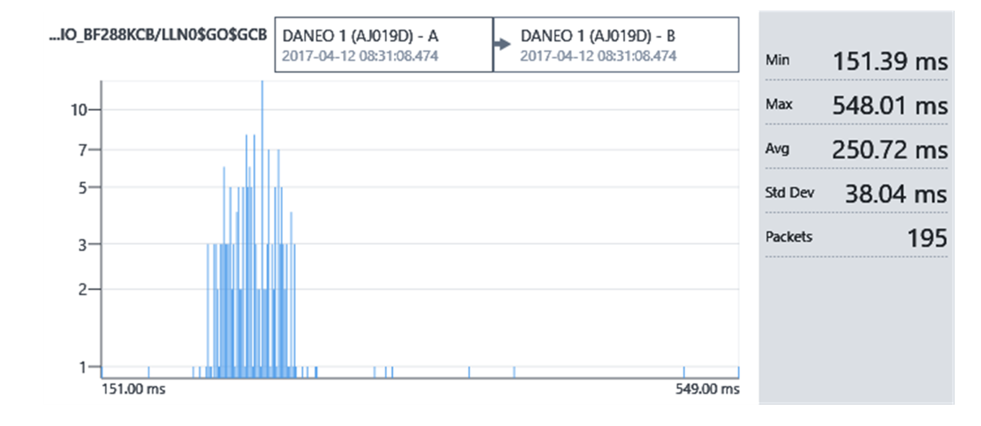
MQTT Performance through Triangle Hosted Broker (expected 150-160 msec average)
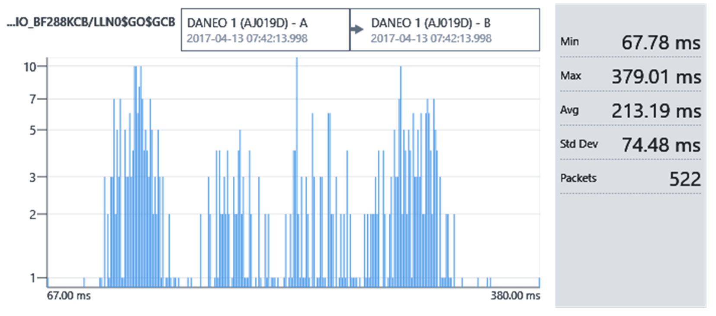
MQTT Performance through Broker hosted on Cable Internet.
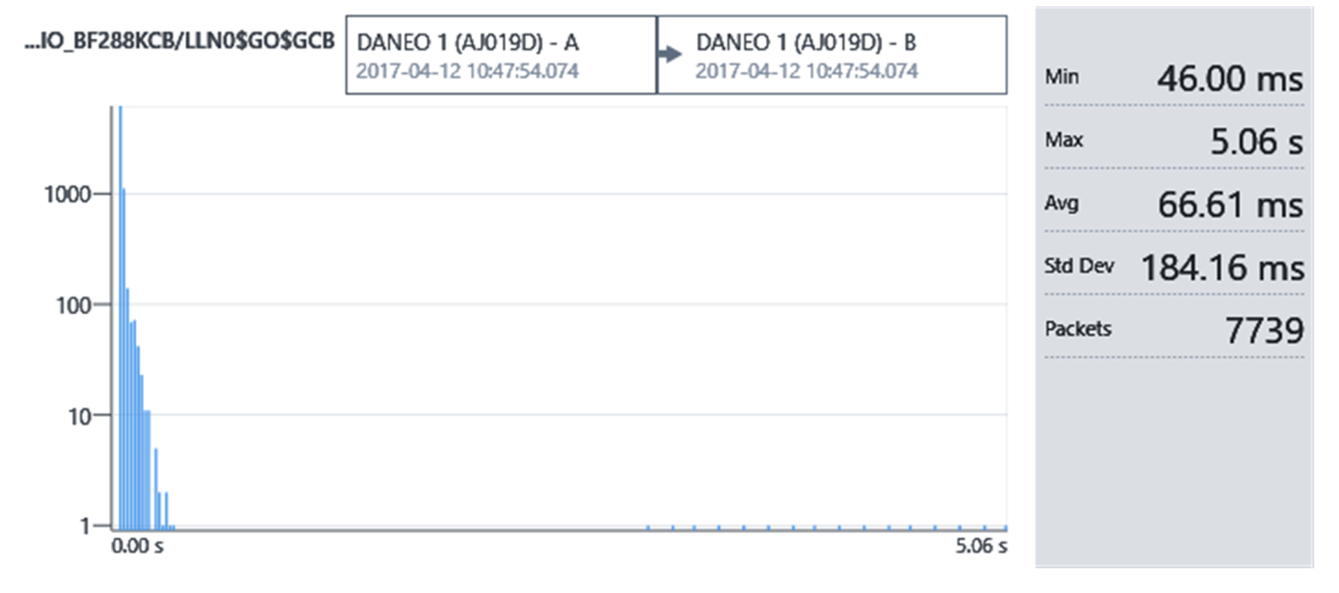GOOGLE Talk Performance – short run
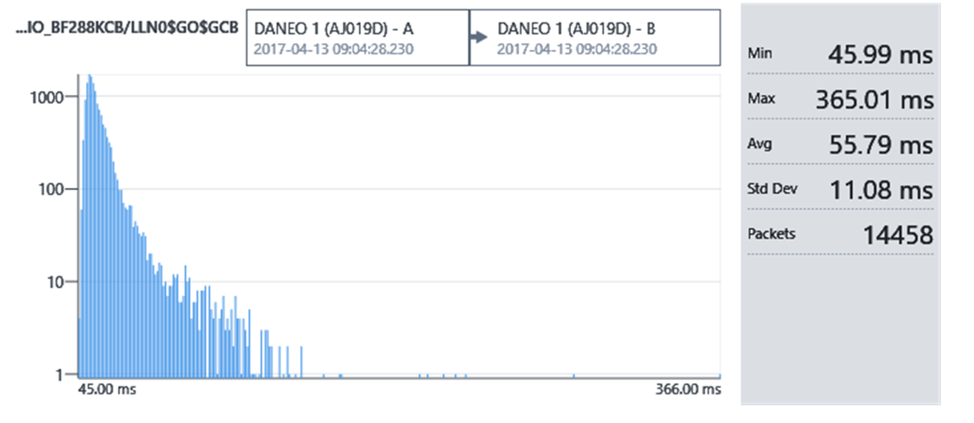GOOGLE Talk Performance – long run
Looking for a subgroup to discuss these differences? Joel, Andreas/

- High Level Use cases and Abstract Test Cases (coordinated by Joel)
See the following folder: http://iec61850.ucaiug.org/2017IOP-NOrleans/IOP%20Documents/General%20Integrated%20Demo%20Information/Test%20procedure%20drafts
Joel will put together a matrix of the ACSI services tested.
Item | Responsible People | Estimated Comp | “Submitted”
IED Isolation for maintenance and testing in the field | Herb Falk  Andreas Klien |  | Yes
IED Replacement | Bruce Muschlitz | 10-03-2017 | Yes
IED Addition to Bay | Vladen | 17-03-2017 | Yes
IED Failure/power down | Michael Haecker | 10-03-2017 | Yes
Clock Failure – Station Bus | Peter Pfisterer (TUV-SUD) |  | Yes
Network Failure | Bruce Muschlitz | 10-03-2017 | Yes
Merging Unit Failure | Dean | 31-03-2017 | Yes
EAP/Failure | Herb, Chan/IT | 17-03-2017 | Yes
Clock Failure – Process Bus | Peter Pfisterer |  | Yes
Cyber Intrusion of GOOSE | Herb Falk | 17-03-2017 | Yes
Reporting to SCADA Masters | Mark and Ursla - Copadata | 12-04-2017
SOE Testing (Logging) | Vladan | 12-04-2017 | Yes
Security Event Monitoring (Syslog, SNMP, IEC 62351-7) | Frances, Herb | 12-04-2017
Secure IEC 61850 MMS | Joel, Ralph, Herb | 12-04-2017
Leap Second Test (Based upon 2.1)  PTP and SNTP | NIST/OMICRON | 12-04-2017
Clock/GPS Time Discontinuity | NIST/OMICRON | 14-04-2017
Matrix of ACSI Services Covered – email: jgreene@trianglemicroworks.com | Joel | Ongoing until all test cases are complete.

- Boot Camp: Herb
People interested in being instructors should send email to herb@sisconet.com and also provide an indication of what they would like to present based upon the current outline.

Logistics

URL for IOP Site: http://iec61850.ucaiug.org/2017IOP-NOrleans/default.aspx
Email Exploder: iec-61850-iop-2017@googlegroups.com
Boot Camp: October 13-14
IOP: Setup: October 14, Testing October 15-19
Hotel: New Orleans Downtown Marriot at the Convention Center
859 Convention Center Blvd
New Orleans, LA 70130
Phone: 504-613-2888
web: http://www.marriott.com/hotels/fact-sheet/travel/msymc-new-orleans-downtown-marriott-at-the-convention-center/
IOP Reservation Link: https://aws.passkey.com/go/UCAIOP (room rate $189 + tax/night)
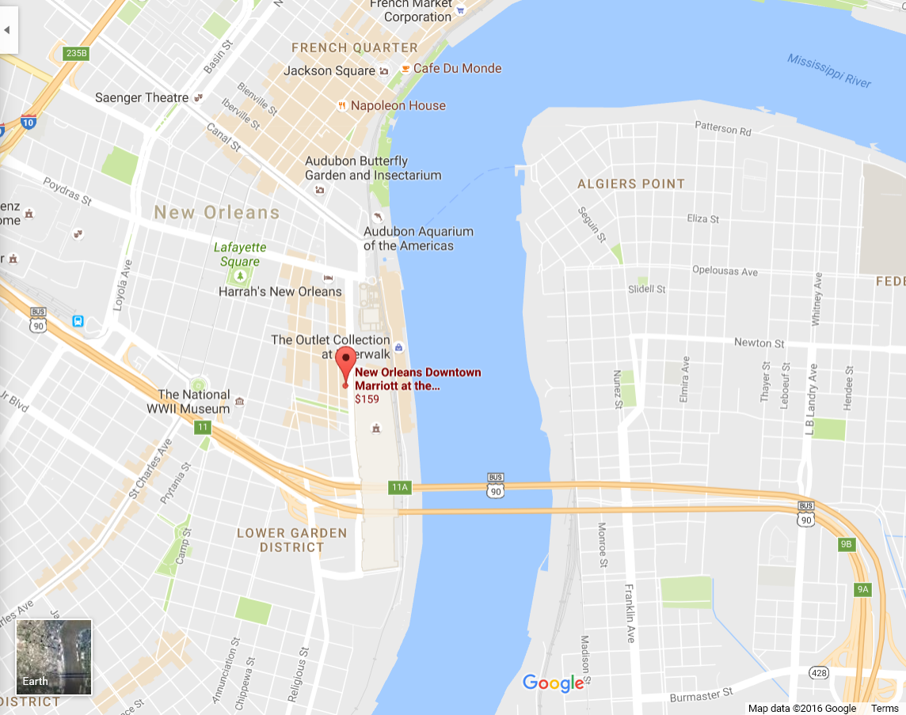
Participation fees:
 | UCA Members (USD) | Non-member  (USD) | Comments
Participating Company | $ 6,500 | $ 8,000 | Includes one Individual if staying at the IOP hotel
Individual Staying at the IOP Hotel | $ 1,000 | $ 1,350 | For non-members, the fee includes UCA membership.
Individual not staying at the IOP Hotel | $ 2,000 | $ 2,350 | For non-members, the fee includes UCA membership.

Participation fees are due by July 1st.
Individual fees can vary after.
Kay will check on hotel cut-off.
Boot Camp fees and logistics:
The Boot Camp has the ability to provide training for 30-40 people. Reservations are first come and will be based upon payment of a registration fee of $250.

WG10 Meetings will be held at Entergy (October 23-27). Entergy is located at:
Entergy
639 Loyola Ave
New Orleans, LA 70113

Known Participants and Witness

Participating Companies
ABB
ArcInfo
CISCO
Copadata
Doble
Efacec
GE-Alstom
GENTEC
Grid Software
Kalkitech
NovaTech
NREC
OMICRON
OSII
Reinhausen
RTDS
Schneider
Schweitzer
Siemens
SISCO
Sprecher-automation
Subnet Solutions
Toshiba
Triangle Microworks
Vizimax

Witnessing Companies
Amprion
BPA
CenterPoint Energy
CEPRI
ComEd
ConEd
DNV/GL
Eandis
EDF
Entergy
Entso-e/Elia
EPRI
Hydro Quebec
It4power
National Grid
NERC
NIST
NYPA
Reliability First
SCE
SWECO
Tesco
TÜV SÜD
UCA

Hold Over

- Introduction
- Discuss philosophy of testing for this IOP –
  - Integrated application
    - Multiple Bays with IEDs and HMIs
    - Communication inter and intra bays
    - Process bus with multiple Merging units
    - Multiple grandmasters
    - LSVS/LGOS
    - Mod/Beh Testing
    - Testing isolation and field testing
    - Application possibilities
      - Transfer Trip Zone1->Zone 2
      - Breaker Fail (similar to Cigre)
    - ED2<->ED1 IOP (maybe have a separate bay for ED1 devices?)
    - SCADA/Gateway (e.g. IEC 61850-90-2 and IEC 61850-7-1)
    - 90-5/Synchrophasor testing
    - NERC/CIP perimeter testing last two days?
    - HSR/PRP
Jun (Doble), Joel Greene, Herb to come up with high level constructs.
  - Sub-testing areas
    - Time Sync (Chan to liaison with IEEE ICAP)
    - NERC/CIP (Herb and Scott, Chan to add user input)
      - Firewall/Router
    - SCL (may not be needed if integrated application is good enough)
    - RGOOSE

- Marketing
  - Entergy to put press release together – Chan to lead
  - EPRI will also socialize
  - What do we want to do with Press attending/reporting on the IOP?

Questions to discuss

- Discuss people being added to the group that have little or no intent to participate or witness (call them lurkers for now).
So accept “lurkers” until they become disruptive.
- Boot Camp Agenda and lead. – Herb to organize.
- Students – Chan to work on scholarship application form. Kay to work out a mechanism to accept corporate donations to a scholarship fund for students. Companies that contribute to the fund get to review and accept the students. Companies should send candidate universities and professor contact information to Chan. Companies that decide that they want certain universities/students present need to indicate that and donate to the fund.

- Network Infrastructure testing

- NIST set of questions from January 18, 2017
  - Who is bringing clocks…
    - 61850-9-3 and C37.238 2011. C37.238 2017 a possibility.
  - External determination Time Inaccuracy – yes it will be tested
  - Holdover testing – probably yes
  - NIST to provide detail about usage of IOP Information desire.
  - Kay will check about government rate in our block or rooms.

SCL Testing Testing Ideas
- Is it possible to mention explicitly test cases including ENTSO-E requirements on SCL: information exchange between functions ; virtual IEDs ; telecommunication network configuration; ... This is of course depending on the WG10 and Jörg TF progress but there are probably already some possibilities ...

Time Sync Testing
Will be facilitated by Bernhard Baumgartner (bernhard.baumgartner@omicron-lab.com).

Action Items
 | Creation  Date | Item | Needed  by | Closed
 | 17-11-2016 | Everybody who doesn’t have UCA IDs, get them and send them to Herb.
 | 17-11-2016 | Jun, Joel, and Herb to start high level discussions on integrated testing. Joel to take the lead. Joel to schedule the first meeting. |  | 10-02-2017
 | 17-11-2016 | Need leads for Time Sync area (Omicron to check and respond if they still want to lead) | 15-12-2016 | 21-11-2016
 | 17-11-2016 | Scott and Herb to work out high level concepts for NERC/CIP |  | 14-12-2016
 | 17-11-2016 | Chan to lead user use case development
 | 17-11-2016 | Chan and Paul to lead on the socialization and marketing for the IOP.
 | 09-02-2017 | Participants need to declare number and type of equipment and LN capability that they intend to bring. Delay in submitting this may result in not being included in the integrated application. Looking for transformer diff, Blocking scheme, breaker failure, transfer trip, line differential, line distance, POTT, etc… | April 15, 2017
 | 09-02-2017 | Fix Witness resource page – Kay.

