Logistics

URL for IOP Site: http://iec61850.ucaiug.org/2017IOP-NOrleans/default.aspx
Email Exploder: iec-61850-iop-2017@googlegroups.com
Boot Camp: October 12-13
IOP: Setup: October 13, Testing October 14-19
Hotel: New Orleans Downtown Marriot at the Convention Center
859 Convention Center Blvd
New Orleans, LA 70130
Phone: 504-613-2888
web: http://www.marriott.com/hotels/fact-sheet/travel/msymc-new-orleans-downtown-marriott-at-the-convention-center/

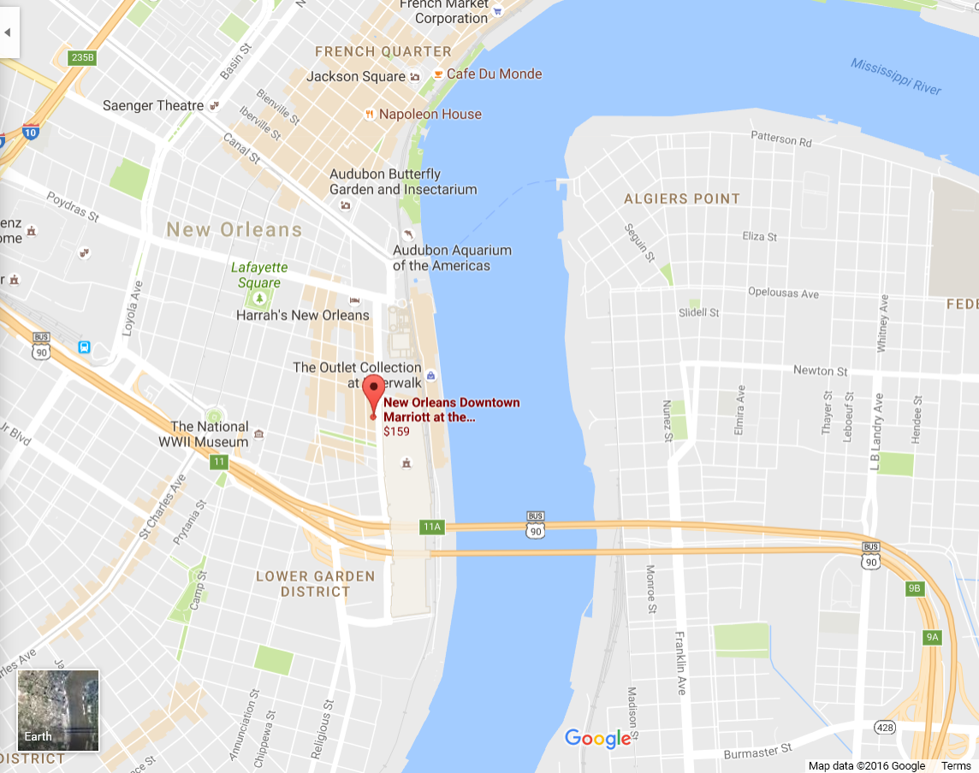

Known Participants and Witness

Participating Companies
ABB
Alstom
ArcInfo
Copadata
Doble
Grid Software
NovaTech
Omicron
OSII
Siemens
SISCO
Sprecher-automation
Subnet Solutions
Toshiba
Triangle Microworks
Vizimax

Witnessing Companies
BPA
CenterPoint Energy
ComEd
ConEd
EDF
Entergy
Entso-e/Elia
EPRI
Hydro Quebec
It4power
National Grid
NERC
NIST
NREC
NYPA
Reliability First
SCE
UCA

Agenda for 11-16-2016

- Introduction
- Discuss philosophy of testing for this IOP –
  - Integrated application
    - Multiple Bays with IEDs and HMIs
    - Communication inter and intra bays
    - Process bus with multiple Merging units
    - Multiple grandmasters
    - LSVS/LGOS
    - Mod/Beh Testing
    - Testing isolation and field testing
    - Application possibilities
      - Transfer Trip Zone1->Zone 2
      - Breaker Fail (similar to Cigre)
    - ED2<->ED1 IOP (maybe have a separate bay for ED1 devices?)
    - SCADA/Gateway (e.g. IEC 61850-90-2 and IEC 61850-7-1)
    - 90-5/Synchrophasor testing
    - NERC/CIP perimeter testing last two days?
    - HSR/PRP
Jun (Doble), Joel Greene, Herb to come up with high level constructs.
  - Sub-testing areas
    - Time Sync (Chan to liaison with IEEE ICAP)
    - NERC/CIP (Herb and Scott, Chan to add user input)
      - Firewall/Router
    - 62351 Security Testing (depends on participation) – low interest at this point in time
    - SCL (may not be needed if integrated application is good enough)
    - Telecom testing (Hydro Quebec to check if this is still needed)
- Marketing
  - Entergy to put press release together – Chan to lead
  - EPRI will also socialize
  - What do we want to do with Press attending/reporting on the IOP?
- Recurring Meetings – Thursday’s @11 AM EST (Next Meeting 15-12-2016).

Action Items
 | Creation  Date | Item | Needed  by | Closed
 | 17-11-2016 | Everybody who doesn’t have UCA IDs, get them and send them to Herb.
 | 17-11-2016 | Jun, Joel, and Herb to start high level discussions on integrated testing. Joel to take the lead. Joel to schedule the first meeting.
 | 17-11-2016 | Need leads for Time Sync area (Omicron to check and respond if they still want to lead) | 15-12-2016
 | 17-11-2016 | Scott and Herb to work out high level concepts for NERC/CIP
 | 17-11-2016 | Chan to lead user use case development
 | 17-11-2016 | Chan and Paul to lead on the socialization and marketing for the IOP.

