IEC 61850 Interoperability Testing
Sept 2019
Charlotte, NC USA

SCL Group Test Cases
Last Updated on - 5th Sept 2019

Introduction 3
Prerequisites 3
Tests from SCL Group 4
Signal Mapping Tests 4
Test 1 : Identify preconfigured Inputs in ICD (SCL-IDENTIFY_PRE_INPUT01) 4
Test 2 : Identify mapping into preconfigured input (SCL-IDENTIFY_PRE_INPUT_MAP02) 4
Test 3 : Identify mapping into IED (SCL-IDENTIFY_ INPUT_MAP03) 4
Supervision Configuration Tests 4
Test 1 : Identify LGOS mapping to subscribed GOOSE (SCL-IDENTIFY_LGOS_MAPPING01) 4
Test 2 : Identify LSVS mapping to subscribed SV (SCL-IDENTIFY_LSVS_MAPPING02) 4
Test 3 : Identify LGOS mapping with LD Name (SCL-IDENTIFY_LGOS_LDNAME_MAPPING03) 4
Test 4 : Identify LSVS mapping with LD Name (SCL-IDENTIFY_ LSVS _LDNAME_MAPPING04) 5
Schema Version mismatch Tests (Ed.1.0/Ed.2.0/Ed.2.1) 5
Tolerance between versions to be verified 5
Test 1 : Import of ICD into SCT (SCL-SCHEMADIFF_ICD_toSCT01) 5
Test 2 : Import of SCD into ICT (SCL-SCHEMADIFF_SCD_toICT02) 5
MustUnderstand Tests 5
Test 1 : Import ICD with MustUnderstand (SCL-MUSTUNDER_ICD_toSCT01) ---- on hold 6
Test 2 : Import SCD with MustUnderstand (SCL-MUSTUNDER_SCD_toICT02) 6
Tests from Integrated Apps 7
Configuration for Integrated App excluded from SCL Testing area 7

Introduction
This document will have the list of test cases to be performed under SCL test area based on substation configuration language. The purpose is to validate that each implementation provides a valid IED Capability Description (ICD) file and that the System Configuration Tool (SCT) to/from IED Configuration Tool (ICT) exchanges are supported as defined in IEC 62351-6.
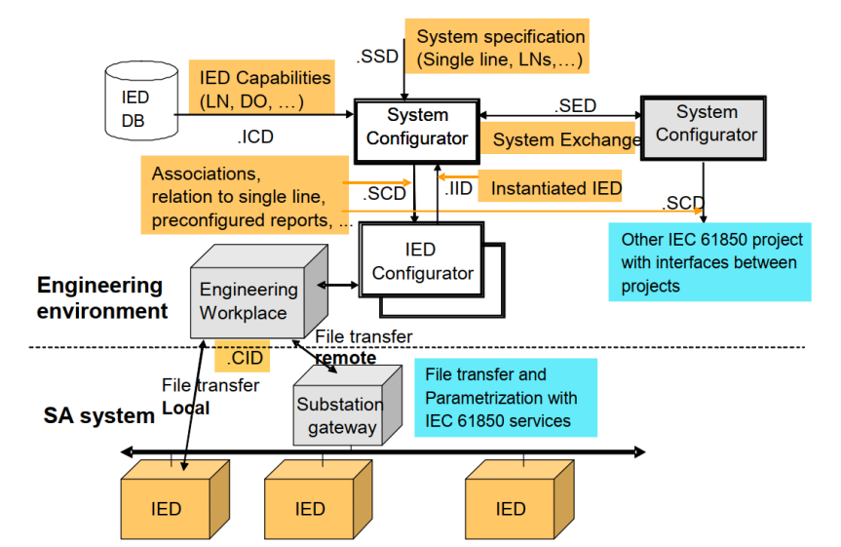
Figure 4: IEC 61850-6 Defined Exchanges
The use of System Specification Description (SSD) files and System Exchange Description (SED) files are also considered if more than one SCT vendors participate. Focus will be more on SCT - ICT tests.
There are two types of tests that need to occur:
1. Relevant SCL Tests based on Integrated Apps configuration
2. SCL Tests defined as part of SCL group discussion

Prerequisites
These steps/tests are required in order to perform SCL Tests:
- ICD validation – tests that the IED Capability Description (ICD) files provided by the vendors are valid. Cross checking using ICD verification tools
- Support of feature in the ICT, as mentioned under the Services section of the IED in SCL file
- Support of feature in the SCT, as claimed by the SCT vendor (Eg: SICS document)

Tests from SCL Group

Signal Mapping Tests

Test 1 : Identify preconfigured Inputs in ICD (SCL-IDENTIFY_PRE_INPUT01)
Expected result
1. SCT import the ICD file successfully and display the preconfigured inputs from ICT

Test 2 : Identify mapping into preconfigured input (SCL-IDENTIFY_PRE_INPUT_MAP02)
SCT to perform GOOSE mapping to the IED to be tested. Signal will be mapped to preconfigured Inputs
Expected result
1. ICT import the SCD file successfully and display the mapping into preconfigured inputs from SCT

Test 3 : Identify mapping into IED (SCL-IDENTIFY_ INPUT_MAP03)
SCT to perform GOOSE mapping to the IED to be tested. Signal can be mapped to any LN.
Expected result
1. ICT import the SCD file successfully and display the mapping from SCT

Supervision Configuration Tests

Test 1 : Identify LGOS mapping to subscribed GOOSE (SCL-IDENTIFY_LGOS_MAPPING01)
Verify whether ICT can accept GOCB reference in LGOS.
Instantiation of LGOS based on GOOSE mapping in IEDs
Expected result
1. ICT import the SCD file successfully and display the mapping of LGOS into Subscribed GOOSE

Test 2 : Identify LSVS mapping to subscribed SV (SCL-IDENTIFY_LSVS_MAPPING02)
Expected result
1. ICT import the SCD file successfully and display the mapping of LSVS into Subscribed SV

Test 3 : Identify LGOS mapping with LD Name (SCL-IDENTIFY_LGOS_LDNAME_MAPPING03)
Expected result
1. ICT import the SCD file successfully and display the mapping of LGOS into Subscribed GOOSE with configured LDName

Test 4 : Identify LSVS mapping with LD Name (SCL-IDENTIFY_ LSVS _LDNAME_MAPPING04)
Expected result
1. ICT import the SCD file successfully and display the mapping of LSVS into Subscribed SV with configured LDName

Schema Version mismatch Tests (Ed.1.0/Ed.2.0/Ed.2.1)
Note: Schema version supported by SCT should be greater than ICT

Tolerance between versions to be verified
1 | 2007 B4 | 2007 B
2 | 2007 B4 | 2003 1.7 (??)
3 | 2007 B4 | ??

Test 1 : Import of ICD into SCT (SCL-SCHEMADIFF_ICD_toSCT01)
Expected result
1. Verify that results of this test by noting schema version of SCT and ICT
2. Also verify how the parameters not supported by ICT are displayed in SCT

Test 2 : Import of SCD into ICT (SCL-SCHEMADIFF_SCD_toICT02)
Expected result
1. Verify that file exported by SCT is as per the schema expected by ICT
2. Also verify how the parameters not supported by ICT are handled by SCT (Eg: Ed.2.0 signal mapping into Ed.1.0 IED)
2. Verify that results of this test by noting schema version of SCT and ICT

MustUnderstand Tests
Reference tests from UCA
1. tTf1 Mandatory
2. tSeh7 Mandatory

Test 1 : Import ICD with MustUnderstand (SCL-MUSTUNDER_ICD_toSCT01) ---- on hold
Set newer version in SCL, for this test, File to be Rejected by Tool
Test is already present in conformance tests. Hold these tests for now.
Expected result
1. SCT import the ICD file successfully and display the Parent node with mustunderstand tag as not editable / recognizable

Test 2 : Import SCD with MustUnderstand (SCL-MUSTUNDER_SCD_toICT02)
Expected result
1. ICT import the SCD file successfully and display the Parent node with mustunderstand tag as not editable / recognizable

Tests from Integrated Apps

Configuration for Integrated App excluded from SCL Testing area
No need to repeat these tests under SCL testing area as these are already covered under Integrated Apps

